 | Robins Class  Stone sCAVENGERS |  |  |  |  | 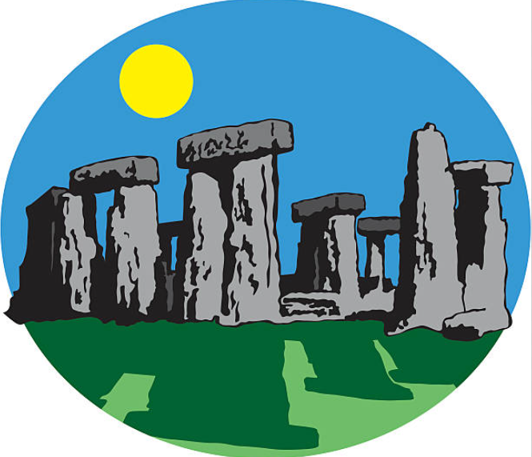 |  | 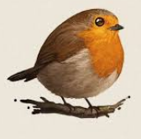
What is this curiosity quest about?
This curiosity quest puts the Peak Park at its heart. Rocks and stones are an important physical feature in the Moorlands landscape. Pupils will learn about the Earth’s natural materials through their science study whilst developing a curiosity about the first people and how they lived exploring what humans need to survive and how the natural world can be used for survival. Pupils will appreciate how nature can be used in art, design and stories. They will gain a fascination for famous fossil discoveries of the past and what we have learnt from them. They will use these fossil discoveries as inspiration for drawing and clay models. They will gain a deeper knowledge of their local area, of the interesting geography and curious places to visit and find on maps.
Big Question 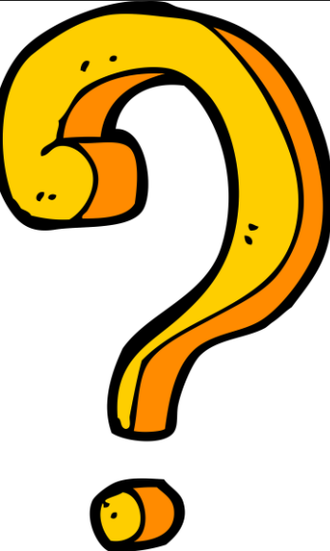 |  |  | Quest Characters 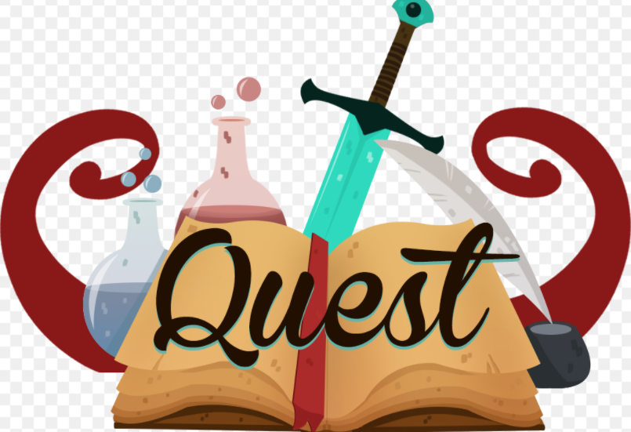 |  |  |  | Core Values
What do people use stones for? |  |  | Mary Anning  Charles Darwin  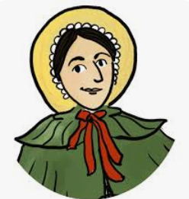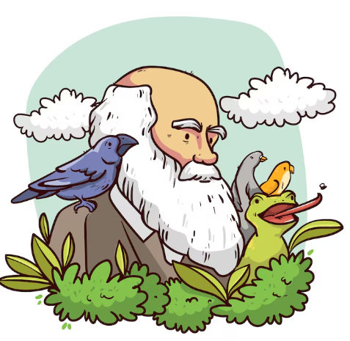 |  |  |  | 
Global Education |  |  | Learning Behaviour |  |  |  | Pupil Character Development
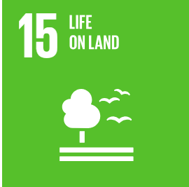 |  |  | I can concentrate like the mustard plant.  I can supress distractions and follow my learning path.  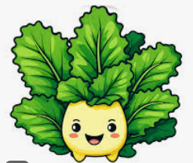 |  |  |  | I look closely.  I am a questioner.  I am a gardener.  I am a countryside ranger.  I am a researcher.  I am an adventurer.  I am an explorer.  I know about my local area and community.  I am an eco-warrior.  I know how to look after my world.  I am spiritual.
 |  |  | Careers
Botanist
Garden designer
Gemologist
Archaelogist
Geologist
KEY AREAS OF LEARNING
Engage, innovate and express
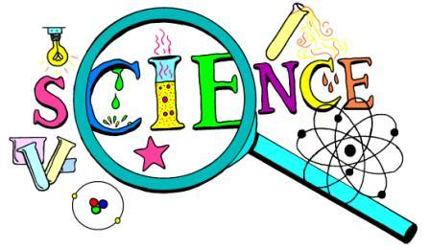  Scripture  Matthew 7 (24-27)  The wise and foolish builders  Big questions  Why are some locations/ habitats more sacred than others?  Awe and wonder  Amazing habitats – bottom of the ocean, hot springs, deserts. |  | .Habitats – A rocky home  Year 1  - I can identify and name a variety of plants that grow in a rocky environment.  - I can explore and answer questions about plants growing in their habitat.  - I can use the local environment throughout the year (Autumn/ Winter) to explore and answer questions about animals in their habitat.  Year 2  - I can explore and compare the differences between things that are living, dead, and things that have never been alive.  - I can identify that most living things live in habitats to which they are suited.  - I can describe how different habitats provide for the basic needs of different kinds of animals and plants, and how they depend on each other.  - I can identify and name a variety of plants and animals in their habitats, including micro-habitats. |  |  | Key Knowledge  Name 3 plants that grow in a rocky habitat in the UK.  Name 3 animals that live in a rocky habitat in the UK.  Name an animal and plant that live in a rocky habitat in another country.  Choose one of the plants. How is it suited to its habitat?  Choose one of the animals. How is it suited to its habitat?  What is a micro-habitat? Give an example.  What does a rocky habitat provide for its plant and animal inhabitants?  Skills  I can sort a range of pictures into living, dead and never been alive.  I can match a range of animals to their habitats.  I can match a range of plants to their habitats.
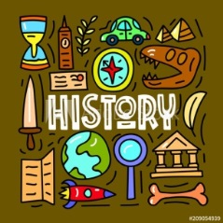  Big questions  Where do we come from?  What makes us human?  Awe and wonder  The most valuable fossil in the world. Stan T-Rex £30 milllion. |  | Events beyond living Memory  Famous Fossils (Mosquito, giant turtle, diplodocus, first human skulls, sabre toothed cat, plesiosaur, Lucy, Maiasaura, Mammoth etc..)  Lives of significant people – Mary Anning  Year 1  - I can find answers to simple questions about the past from sources of information.  - I can ask questions about sources of evidence.  - I know and can recount episodes from stories about the past.  Year 2  - I can observe sources to answer questions about the past.  - I can ask questions which show my knowledge and understanding of History. |  |  | Key Knowledge  Name all of the famous fossils you have learnt about.  Explain 3 of them.  What did scientists and archaeologists learn from these fossils about the past?  How is a fossil formed?  Tell the story of Mary Anning and how she found the plesiosaur fossil.  Skills  I can use a source of information to find an answer to a question.  I can ask an interesting question about fossils.
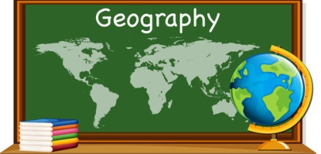  Scripture:  Deuteronomy 32:4  ‘He is the rock.’  Big questions:  Why should we protect the Peak Park?  Awe and wonder:  The story of Thor’s cave |  | Physical features of the locality/ Vocabulary/ Use of aerial photos  Year 1  - I can name some physical features.  - I recognise that the map is about a place.  - I can investigate my surroundings.  - I can make observations about where things are e.g. within my school or local area.  - I can draw a picture map.  Year 2  - I know some key physical features in my local area and why they are important.  - I can use geographical vocabulary to talk about key physical features.  - I can use aerial photographs and simple maps to locate features.  - I can draw a picture map wih details. |  |  | Key Knowledge  Name as many physical features in the environment of Hollinsclough as you can.  Why are the ‘rocks/ stones’ around Hollinsclough important?  Why are the streams/ river important?  What do you know about rocks?  Skills  I can find the physical features of Hollinsclough on a map and on an aerial photograph.  I can draw a picture map.
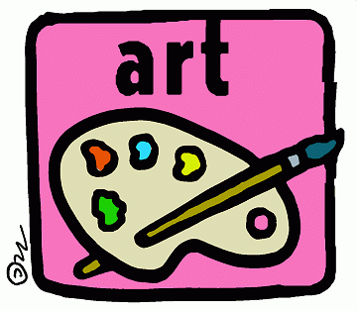  Scripture:  Isiah 64:8  ‘But now O Lord, you are our Father, we are the clay, and you are our potter; we are all the work of your hand.’  Big questions  Why is clay useful to us?  Awe and wonder  Clay used in History to treat ailments. |  | 3D Form – Clay Fossils  Year 1  - I can manipulate clay in different ways (rolling, kneading, shaping) exploring shape and form.  - I can make my own sculpture with clay.  Year 2  - I can manipulate clay for different purposes (pots and models).  DRAWING  Year 1  - Use a sketchbook to gather and collect artwork.  - I am beginning to explore the use of line, shape and colour.  Year 2  - I understand the basic use of a sketchbook and work out ideas for drawings.  - Draw for a sustained period of time from the figure and real objects, including single and grouped objects.  - I experiment with the visual elements; line, shape, pattern and colour. |  |  | Key Knowledge  Explain how to make a clay model.  Where does clay come from?  What does a good artist do?  Skills  I can observe carefully to draw detailed sketches of fossils and other natural forms.  I can work carefully and take my time with my drawing.  I can mould a piece of clay into a finished model.
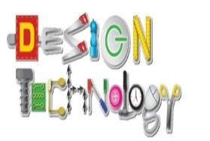  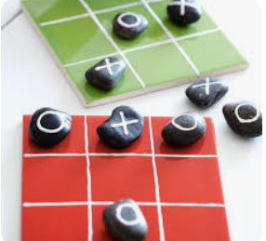  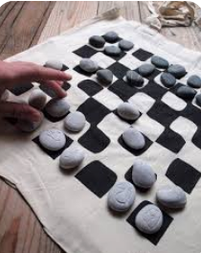 |  | DESIGN/MAKE/EVALUATE  An outdoor board game using stones.  - I can generate my ideas through drawings.  - I can design a purposeful and appealing product. |  |  | Key Knowledge  Skills  I can draw a design for a stones board game.
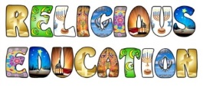 |  | Theme: CREATION  Key Question: Who made the world? (Core)  Religion: Christianity  - I can retell the story of creation from Genesis 1:1–2.3 simply.  - I can recognise that ‘Creation’ is the beginning of the ‘big story’ of the Bible.  - I can say what the story tells Christians about God, Creation and the world.  - I can give at least one example of what Christians do to say thank you to God for the Creation.  - I can think, talk and ask questions about living in an amazing world.  I know that God has a unique relationship with human beings as their Creator and Sustainer. |  |  | Key Knowledge  God created the universe. Why is the Earth and everything in it important to God?  What relationship do humans have with God?  Why should humans care for the Earth?  Skills  I can retell the story of creation from Genesis 1:1–2:3 simply.  I can say what the story tells Christians about God, creation and the world.  I can give at least two examples of what Christians do to look after the world for God.  I can think, talk and ask questions about living in an amazing world.
 |  | What is technology and how can we use it safely?  Computing systems and networks – Technology around us  Year 1  - I can identify technology.  - I can identify a computer and its main parts.  - I can use a mouse in different ways.  - I can use a keyboard to type on a computer.  - I can use the keyboard to edit text.  Year 2  - I can recognise the uses and features of information technology.  - I can identify the uses of information technology in the school.  - I can identify information technology beyond school.  - I can explain how information technology helps us.  - I can explain how to use information technology safely.  - I can recognise that choices are made when using information technology. |  | Year 1  Knowledge  How does technology help us?  Name the main parts of a computer.  What rules help to keep us safe and healthy on the computer?  Year2  Key Knowledge  Give examples of computers.  Describe how computers are used?  Give examples of Information technology.  Describe how IT is used?  Why do we use IT?  How do rules for computers and IT help to keep you safe?  What are those rules? | Year 1  Skills  I can locate examples of technology in the classroom.  I can switch on and log into a computer.  I can use a mouse to click and drag.  I can click and drag to make objects on a screen.  I can use a mouse to create a picture.  I can use a mouse to open a program.  I can delete letters.  I can open my work from a file.  I can use the arrow keys to move the cursor.  Year 2  Skills  I can sort school IT by what it’s used for.  I can find examples of information technology.  I can sort IT by where it is found.  I can demonstrate how IT devices work together.  I can recognise common types of technology.  I can identify the choices that I make when using IT.  I can use IT for different types.
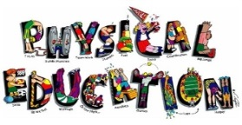
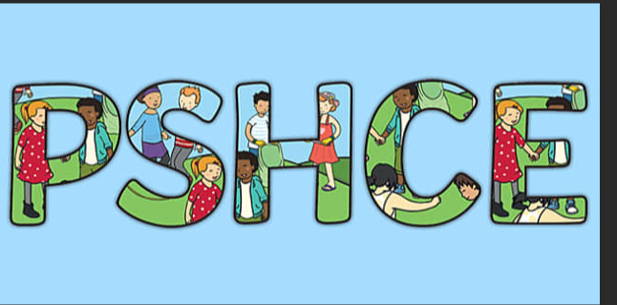  Scripture:  Ephesians 6:1-4  Psalm 127:3-5  Big Question  Can friends be more important than family?  Awe and wonder  Different types of family (explored through stories). |  | How are families different?  Relationships: Family  - I can talk about the people who care for me and give me love, and the things that they do to share that care.  - I can talk about the ways that I might show that I enjoy being in my family.  - I can show that I understand that different people have different kinds of families (including single parents, same-sex parents, step-parents, blended families, foster parents, multi-generational families).  - I can talk about what is the same across all families.  - I can say who I might go to for help if I feel unsafe or unhappy in my family. |  |  | Key Knowledge  Who would you go to for help if you felt unsafe?  Talk about someone who loves you and say what they do to show you they care.  What similarities do all families have?  What differences do families have?  Skills  I can listen to and show respect for the family lives of others.
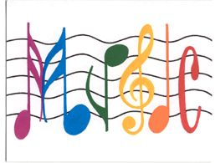
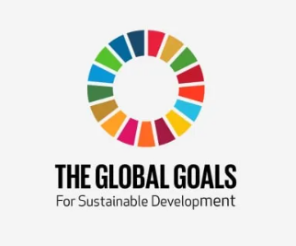 |  | 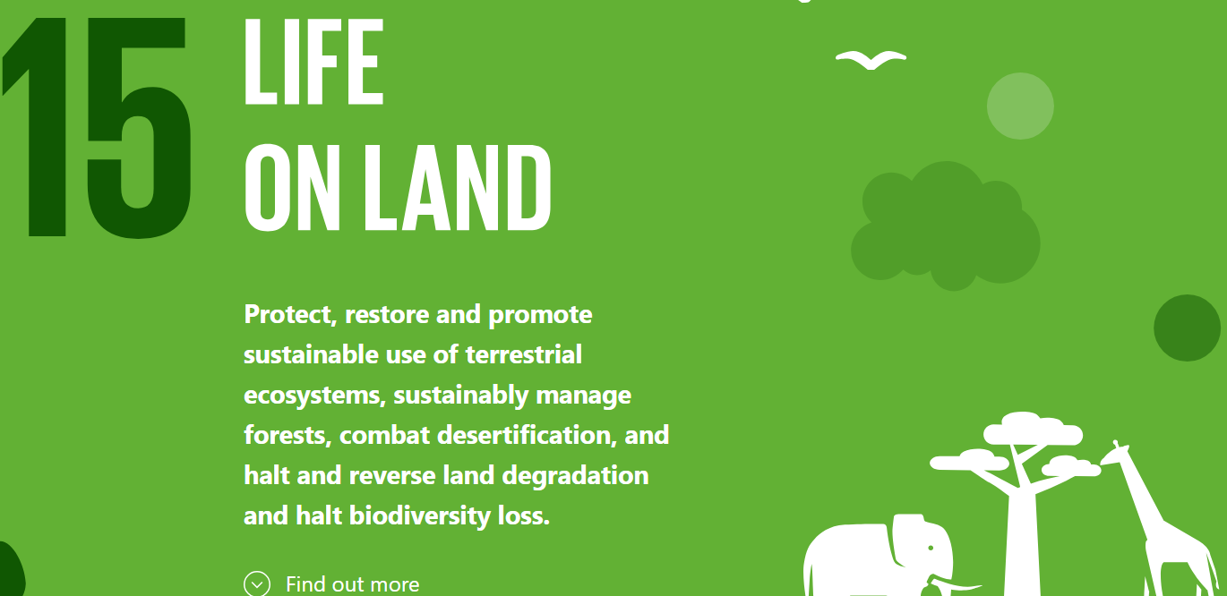 |  |  | 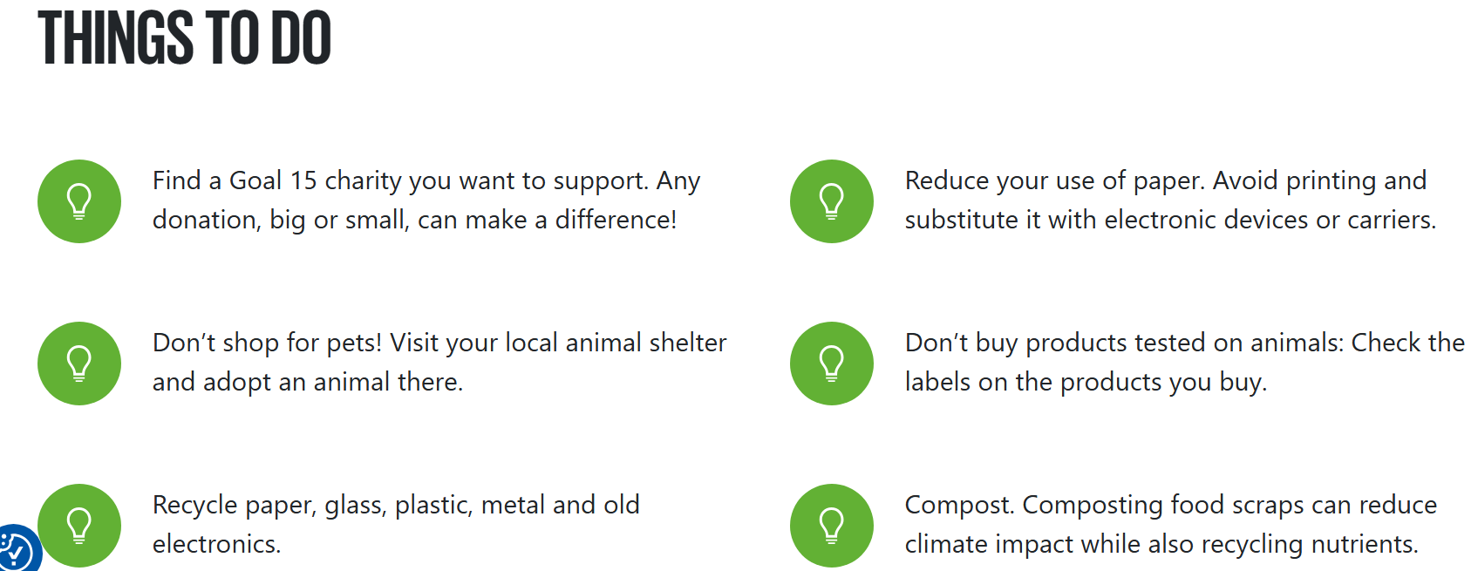  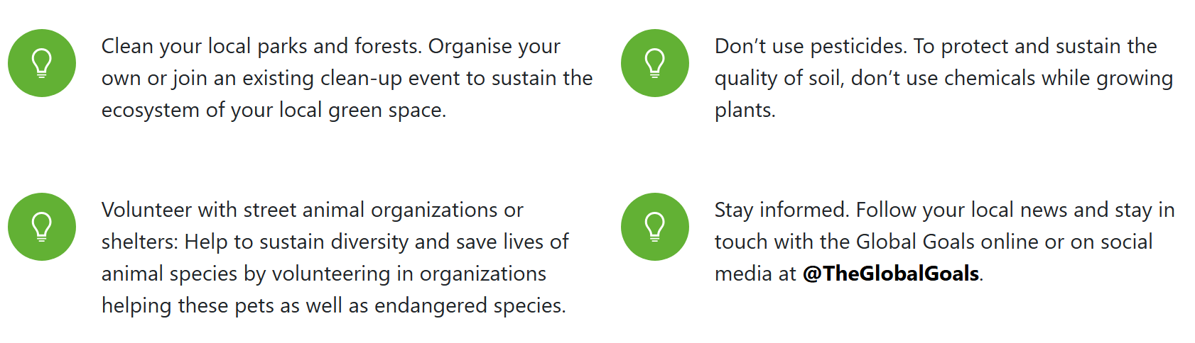
Possible Texts |  | 