EYFS (Reception) Curriculum Long Term Plan Year A (2025-2026)
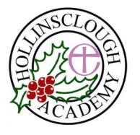 |  | Autumn Term |  | Autumn 2nd Half | Spring 1st Half |  |  |  |  | Spring 2nd Half |  | Summer 1st Half | Summer 2nd Half
Whole School Curiosity Quest  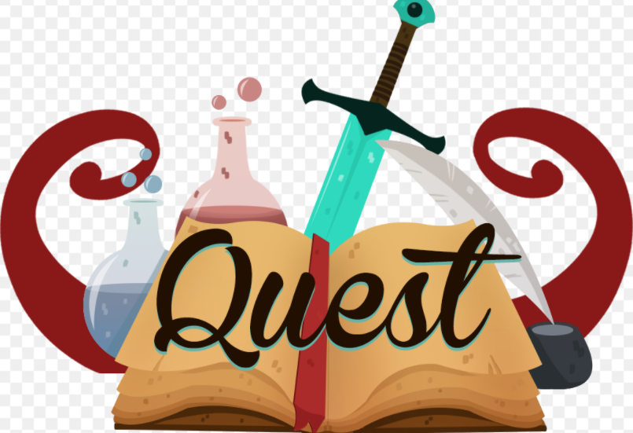 |  | 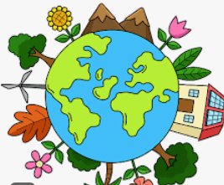  Wonderful World |  | 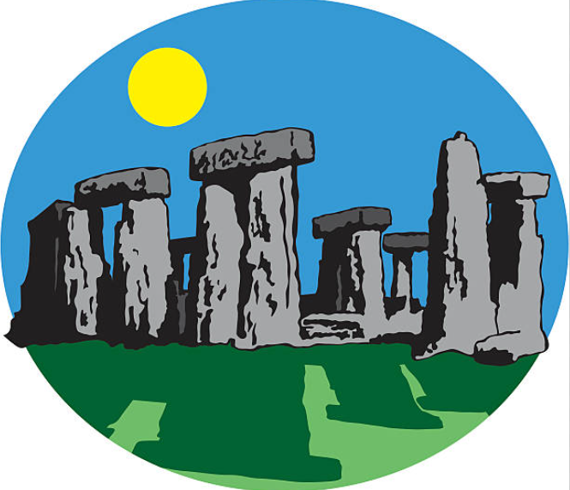  Stone sCAVENGERS | 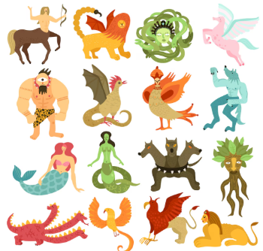  Myths and Legends |  |  |  |  | 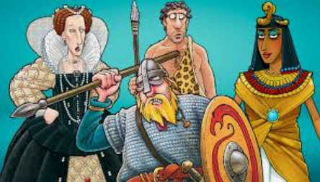  Horrible Histories |  | 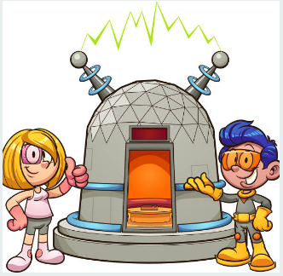  Time Travellers | 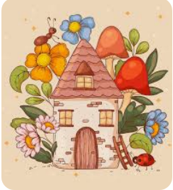  Home Sweet Home
Big question  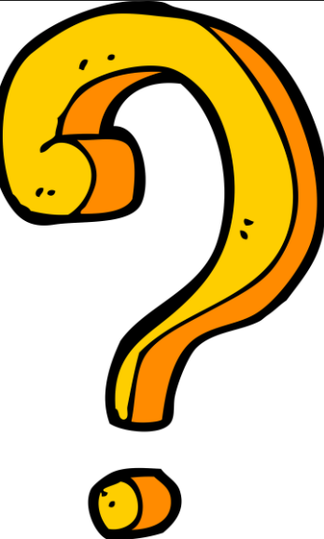 |  | What makes our world wonderful? |  | What do people use stones for? | Why do people make up stories? |  |  |  |  | How has the past shaped the present and future? |  | Would you want to travel back in time? | Is home sweet home a building?
Linking Themes |  | Autumn  Our Local Area  Harvest time  Birthdays  Countries/ music |  | Winter  Diwali / Hannukah  Nursery Rhyme Week  Remembrance Day  Bonfire Night  Christmas | Valentine’s Day  Chinese New Year  Fairytales  Planting/ gardening/ spring |  |  |  | World Book Day  Comic Relief  Mother’s Day  Lent / pancake day  Easter |  |  | Ramadan  Eid | Father’s Day  Transition
Core Values |  |  |  |  |  |  |  |  |  |  |  | 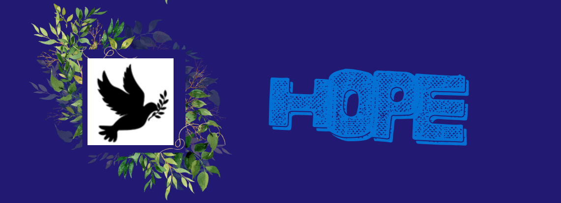
Learning Behaviours |  | I explore like the trailing ivy plant.  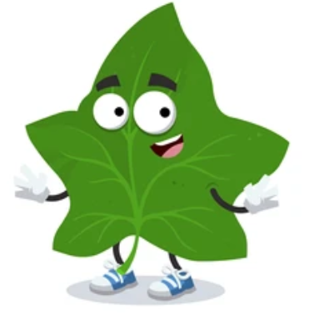  I want to explore the world around me.  I can try new things like the pea plant.  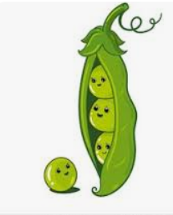  I use what I know to find new ways to do things. |  | I can concentrate like the mustard plant.  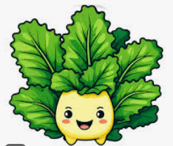  I can supress distractions and follow my learning path.  I can make my learning stick like the sticky weed plant.  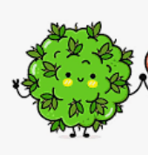  I find ways to remember what I have learnt. | I can collaborate like fungi.  I can link with others to achieve magical things.  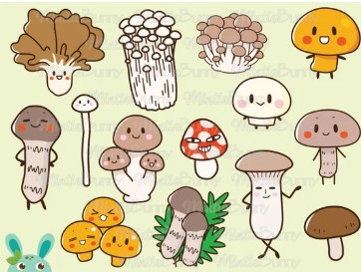 |  |  |  | I stand proud like a bird of paradise plant.  I am proud of my achievements.  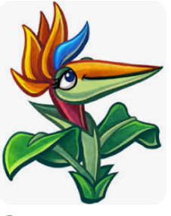 |  |  | I am resilient like a cactus.  I keep going persevere even when I find things difficult.  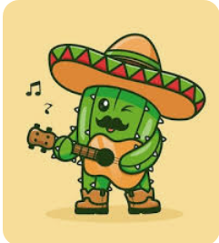 | I can solve problems like the venus fly trap plant.  I can think of my own ideas and be reflective.  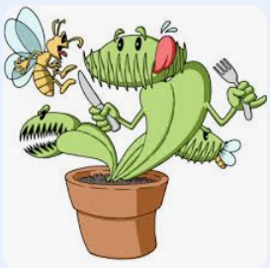  I can challenge myself like the resurrection plant.  I don’t always choose the easy option.  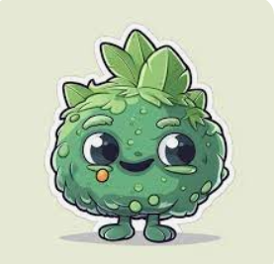
Personal, Social and Emotional Development  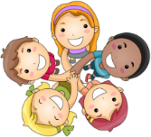 | Self Regulation  Reception | Knowledge  I know why I need to focus.  I know a range of emotions. |  | Knowledge  I know some ways in which people show their feelings. | Knowledge  I know what I need to do to show I am focusing on my learning. |  |  |  |  | Knowledge  I know what the consequences are to poor behaviour choices.  I know what kindness is.  I can give examples of how to show kindness. |  | Knowledge  I know an emotion is what I am feeling.  I know a range of words to describe my emotions.  I know some techniques to keep myself happy and calm.  I know some of the things I am good at. | Knowledge  I know what a goal is.  I know what my own goals are.
 | Self Regulation  Reception | Skills  I can follow one step instructions.  I can recognise different emotions.  I can focus during short whole class activities.  I welcome distractions when upset. |  | Skills  I can talk about how I am feeling and consider others’ feelings.  I can regulate my impulses. | Skills  I can focus for longer whole class lessons. |  |  |  |  | Skills  I can identify and moderate my own feelings socially and emotionally.  I can identify kindness.  I understand that I am responsible for my own behaviour. |  | Skills  I can control my emotions using a range of techniques.  I can talk about my own abilities positively.  I can say what other children in my class are good at. | Skills  I can follow instructions of three steps or more.  I know that I am a unique and valued individual.  I can regulate my own behaviour, I can set my own goals.  I can show resilience and perseverance.
 | Managing self  Reception | Knowledge  I know some things that make a good relationship between people.  I know why we need to have rules. |  | Knowledge  I know why I need to wash my hands throughout the day.  I know some healthy foods.  I know some unhealthy foods. I know why I should eat healthy foods. | Knowledge  I know what some of my achievements have been so far this year.  I know what is special about me.  I know what my talents are.  I know what is special about my friends.  I know what perseverance is. |  |  |  |  | Knowledge  I know what makes me an individual.  I know some ways to keep myself healthy.  I know how to keep myself clean. |  | Knowledge  I know why I should control my feelings and impulses. | Knowledge  I know what healthy food choices would be.  I know why it is important that I get enough sleep.  I know why it is important to limit my screen time.  I know why it is important to exercise.  I know why it is important I keep my body clean.
 | Managing self  Reception | Skills  I am building constructive and respectful relationships in school.  I can tidy away my own equipment. |  | Skills  I can wash my hands independently.  I can complete a jigsaw in a group. | Skills  I am proud of my achievements.  I am starting to show resilience and perseverance in the face of a challenge.  I can complete a jigsaw with a partner. |  |  |  |  | Skills  I show respect to those around me.  I am developing independence when dressing and undressing.  I can make positive choices with my health and well-being.  I explore personal hygiene through water play using soap, dolls, clothes etc. |  | Skills  I can manage my own basic needs independently.  I can dress myself independently.  I can control my impulses when my needs are not met and when involved in a conflict. | Skills  I can show a ‘can do’ attitude. I can show resilience and perseverance in the face of a challenge.  I am making good choices to help me stay healthy.  I can organise and tidy up materials.  I can complete a jigsaw independently. (challenge -24+ pieces).
 | Building Relationships  Reception | Knowledge  I know who I can ask for help. |  | Knowledge  I know what makes a good friend. | Knowledge  I know some strategies I can use to help me take turns. |  |  |  |  | Knowledge  I know how to show I am listening. |  | Knowledge  I know why I need to take turns. | Knowledge  I know some ways to sort out disagreements with others.
 | Building Relationships  Reception | Skills  I can seek support from adults.  I have the confidence to speak to my peers and adults. |  | Skills  I am beginning to develop friendships. | Skills  I can take turns.  I can seek others to share experiences. |  |  |  |  | Skills  I can listen to the ideas of other children and agree on a solution and compromise. |  | Skills  I can work as a group taking turns and sharing with others. | Skills  I am beginning to find solutions to quarrels and negotiate and talk with others.
Communication and Language  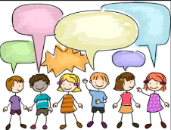 | Listening Attention and UnderstandingReception | Knowledge  I know why listening is important. |  | Knowledge  I know some simple rhymes, patterns and songs. | Knowledge  I know what I need to do to show I am a good listener. |  |  |  |  | Knowledge  I know what some of the meanings of some of the new topic vocabulary.  I know what questions to ask to find out more. |  | Knowledge  I know what I need to do to show I am a good listener. | Knowledge  I know which questions to ask to check my understanding.
 | Listening Attention and UnderstandingReception | Skills  I can understand how to listen carefully.  I engage in daily story time.  I can maintain attention in whole class/ groups.  I can follow instructions with 1 part. |  | Skills  I am beginning to understand how and why questions.  I can listen carefully to rhymes and am beginning to recognise rhyming patterns.  I can listen / maintain attention in familiar and new situations.  I can follow instruction with 2 parts. | Skills  I can listen to and talk about stories building familiarity and understanding.  I can recite simple rhymes, poems and songs.  I can listen attentively in a range of situations.  I can maintain attention during activities.  I can consider the listener and take turns.  I can retell a story.  I can follow a story without pictures or props showing understanding. |  |  |  |  | Skills  I can answer who, what, where, why or how? Questions.  I can listen and talk about stories in depth.  I can ask questions to find out more and clarify understanding. |  | Skills  I can understand and respond to a question such as who, what, where, when, why and how.  I can listen and understand instructions while busy with another task.  I can maintain an activity whilst listening.  I can follow instructions with 3 or 4 parts. | Skills  I can have conversations with adults and peers with back-and-forth exchanges.  I can attend to others in play.  I can make comments and clarify my thinking with questions.
 | Speaking  Reception | Knowledge  I know how to greet people. |  | Knowledge  I know a wide range of vocabulary related to our learning quest. | Knowledge  I know that I need to speak in full sentences. |  |  |  |  | Knowledge  I know what a non-fiction book is. |  | Knowledge  I know why I need to sequence my ideas and events. | Knowledge  I know a wide range of vocabulary related to stories.
 | Speaking  Reception | Skills  I can talk in front of small groups and my teacher offering my own ideas.  I can use social phrases as part of my daily routines eg, ‘good morning’ and ‘how are you’?  I can use sentences with 4-6 words. |  | Skills  I can use new vocabulary throughout the day.  I can talk in front of small groups and my teacher offering my ideas.  I can use talk to organise play. | Skills  I can talk in sentences using conjunctions, e.g. and, because.  I can articulate ideas in well- formed sentences.  I am beginning to use past tense.  I can recount past events. |  |  |  |  | Skills  I engage in non-fiction books and can use new vocabulary in different contexts.  I use talk to work out problems and organise my thinking.  I can re-tell stories and create my own narratives. |  | Skills  I can use talk to organise, sequence and clarify my thinking, ideas, feelings and events in detail.  I can express ideas about my feelings and experiences.  I can use language to reason. | Skills  Children will use talk in sentences using a range of tenses.  Children will use talk to explain how things work and why they might happen in order to solve problems.  Re-tell story with repetition and own words.  Speak in well-formed sentences with some detail.
Physical Development  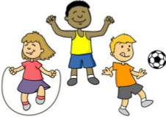 | Gross motor  Reception | Knowledge  I know vocabulary to describe ways to move. |  | Knowledge  I know a range of different balances. | Knowledge  I know some different things I can do with a ball. |  |  |  |  | Knowledge  I know a range of different balances.  I know what I have to land safely. |  | Knowledge  I know a range of ways to travel across apparatus. | Knowledge  I know the rules for simple games.
 | Gross motor  Reception | Skills  I can move safely in a space.  I can move in a variety of ways; walking, jumping, hopping, running and skipping.  I can improve my footwork  co-ordination.  I can perform a static balance on one leg.  I can pretend to be an animal and move in that way. |  | Skills  I am moving more fluently with developing control.  I can explore different ways to travel using equipment.  I can walk a balance bike.  I can perform a balance, jump and land.  I can perform a static seated balance.  I can balance a beanbag on parts of my body. | Skills  I can move safely and confidently in a variety of more challenging ways.  I can control a ball in different ways.  I can improve my co-ordination with a ball.  I can balance on a variety of equipment and climb.  I can explore and describe different movements.  I can perform a counterbalance with a partner. |  |  |  |  | Skills  I am developing a range of balls skills including throwing, catching and kicking.  I can jump and land safely from a height.  I can balance on a bike down an incline.  I can use my core muscle strength to achieve a good posture when sitting.  I can perform a dynamic balance on a line.  I can perform a static balance stance. |  | Skills  I can move safely with confidence and imagination, communicating my ideas through movement and using a range of large and small apparatus.  I can pedal and maintain balance on a bike.  I am developing overall body strength, balance,  co-ordination and agility.  I can link two movements together with control and skill.  I can improve my co-ordination skill with sending and receiving balls.  I can complete an obstacle course. | Skills  I can play by the rules.  I can play hopscotch.  I can play chase and energetic games (e.g stuck in the mud, beans, sharks).  I can develop my coordination and agility.  I can pedal and maintain balance on a bike whilst manoevering.  I can chase a ball with agility.  I can perform static balances during floor work.
 | Fine motor  Reception | Knowledge  I know how to hold a pencil.  I know the names of tools used in the classroom. |  | Knowledge  I know how to hold a pair of scissors. | Knowledge  I know that I need to turn the paper as I cut with scissors. |  |  |  |  | Knowledge  I know the names of cutlery. |  | Knowledge  I know that I need to turn the paper as I cut with scissors.  I know how to hold and thread a needle. | Knowledge  I know the names of tools used in the classroom.
 | Fine motor  Reception | Skills  I am beginning to use a tripod grip when using mark making tools.  I can use tweezers to pick up small objects.  I can tear paper. |  | Skills  I can accurately draw lines, circles and shapes to draw pictures.  I can cut continuously with scissors to make lines or snips. | Skills  I can handle scissors, pencil and glue effectively.  I can cut along curved lines with scissors.  I can use moulding tools with malleable materials. |  |  |  |  | Skills  I can use cutlery appropriately.  I can thread fine beads.  I can use tweezers to pick up fine objects.  I can weave yarn around a piece of card. |  | Skills  I can hold scissors correctly and cut out small shapes.  I can use lacing cards with detailed patterns.  I can develop basic sewing skills.  I can make a stitch in and out of the fabric.  I can make long and short stitches.  I can cut the thread and finish off. | Skills  I can form letters correctly using a tripod grip.  I can make peg board patterns.
Literacy
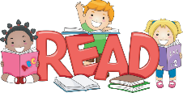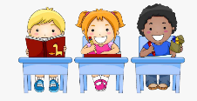
 | Comprehension  Reception | Knowledge  I know the difference between text and illustrations. |  | Knowledge  I know which are my favourite books.  I know what a character is. | Knowledge  I know what illustrations are.  I know what a prediction is. |  |  |  |  | Knowledge  I know what a character is.  I know what a prediction is. |  | Knowledge  I know the difference between types of text. | Knowledge  I know what an author is.  I know what an illustrator is.  I know a wide range of vocabulary related to stories.
 | Comprehension  Reception | Skills  I can look at a book, hold it the correct way and turn pages.  I can explain what is happening in a simple picture in a familiar story.  I can complete a repeated refrain in a rhyme/ story. |  | Skills  I can engage and enjoy an increasing range of books.  I can respond to who, where, what questions linked to text and illustrations.  I can make simple inferences to answer yes/no questions about characters emotions in a picture book, read aloud to them.  I can sequence 2 events from a familiar story using puppets or pictures. | Skills  I can act out stories using recently introduced vocabulary.  I can use picture clues to help read a simple text.  I can make a simple prediction based on a straightforward story read aloud to them.  I show understanding of words and phrases.  I express a preference for a book or rhyme from a limited selection.  My play is influenced by books. |  |  |  |  | Skills  I can talk about the characters in the books I am reading.  I can re-tell stories in the correct sequence, drawing on language patterns of stories.  I can suggest how an unfamiliar story may end.  I can give a simple opinion on a book.  I can innovate a well-known story through play with support. |  | Skills  I can retell a story using vocabulary influenced by my book.  I can correctly sequence a story or event using pictures and/or captions.  I can make inferences to answer a question beginning ‘why do you think?’ in a picture book read to them.  I can act out a story in play using gestures and actions. | Skills  I can answer questions about what they have read.  I can act out stories through role play activities and using props.  I can innovate a known story.  I can recall the main points in text in the correct sequence.  I can say whether I like or dislike a book.  I can give a simple justification.  I am showing understanding of less familiar words.
 | Word Reading  Reception | Knowledge  I know grapheme phoneme correspondence of 16 letters. |  | Knowledge  I know grapheme phoneme  correspondence of 19 letters. | Knowledge  I know taught digraphs (ck,ff,ss,ll). |  |  |  |  | Knowledge  I know 9 vowel digraphs –  ai,ee,oa,oo,ar,or,ur,ow,oi.  I know the trigraph igh. |  | Knowledge  I know trigraphs ear, ure, air.  I know vowel digraph er. | Knowledge  I know all 42 grapheme phoneme correspondences.
 | Word Reading  Reception | Skills  Phase 2  I can orally blend and segment simple words. |  | Skills  Phase 2  I am beginning to read captions and sentences.  I can blend sounds into VC and CVC words orally.  I can read a few common exception words. the, to, no, go. | Skills  Phase 2  I can recognise digraphs in words and blend the sounds together to read words.  I can read phase 2 phonic phrases.  I can read tricky words the, to, no, go, I. |  |  |  |  | Skills  Phase 2/3  I can read words containing digraphs,j,v,w,x,z,zz,qu,sh,th,ch,ng.  I can read tricky words the, to, he, she, we, me, be, was,my.  I can read phase 2/3 books. |  | Skills  Phase 3  I can read longer sentences containing phase 4 words and tricky words.  I can read 4 double consonants.  I can read phase 3 books.  I can read tricky words they, her, all, are.  I can read 2 syllable words and captions. | Skills  Phase 4/5  I can read phase 4 books.  I can read tricky words do, when, out, what, said, have, like, so.  I can blend all 42 phonemes to read CVC words.  I can read CVCC words.  I can blend adjacent consonant – sd, sk, cr, sl, tr, dr, scr, st, spr, pl, sw, fr, sn, sm, vr.
 | Writing  Reception | Knowledge  I understand that thoughts can be written down.  I know that marks have meaning. |  | Knowledge  I understand that thoughts and stories can be written down.  I know that after a word is a space. | Knowledge  I know that groups of letters make up a word and a group of words make sentences.  I know that writing goes from left to right and top to bottom. |  |  |  |  | Knowledge  I know how to form clear ascenders and descenders. |  | Knowledge  I know all grapheme, phoneme letter correspondences.  I know why I need to use a capital letter and full stop. | Knowledge  I know why I need to use a capital letter and full stop.  I know about different types of stories.  I know about different types of information text.
 | Writing  Reception | Skills  I give meanings to the marks I make.  I can write my name, I write it from a name card or I try to write it from memory.  Handwriting – draw lines and circles.  Spelling – Orally segment sounds in simple words.  Writing process progression  Adults scribe and write each word, child decides on the content. |  | Skills  I can copy adult writing behaviour, e.g writing messages, writing on a whiteboard.  I can write letters and strings, sometimes in clusters like words.  Handwriting  I can form letters in my name correctly.  I can form lower case letters correctly.  Spelling  I can orally spell VC and CVC words by identifying sounds.  I can write my own name.  Writing process progression  Adults are dictated to by the child, the adult says the word as it is written pointing out gaps and punctuation.  Child begins to write the initial sound of a word and the adult continues to write the other parts of the story. | Skills  I can write words representing the sounds with a letter/letters.  I can write lower case letters correctly.  Handwriting  I am showing a dominant hand. I am beginning to form recognisable letters.  Spelling  I can spell to write VC and CVC words independently using phase 2 graphemes.  I can orally compose a sentence and hold it in memory.  Writing process progression  Child continues to write the initial sound of a word which may develop to a VC and a CVC word and the adult continues to write the other parts of the story. |  |  |  |  | Skills  I can write labels/phrases representing the sounds with a letter/letters.  I am beginning to form capital letters correctly.  Handwriting  I can hold a pencil effectively to form recognisable letters.  Spelling  I can spell to write VC, CVC and CVCC words independently using phase 2 and 3 graphemes.  I can spell some tricky words the, to, no, go independently.  I can orally compose a sentence with simple conjunctions.  Writing process progression  More phonetically correct words are written by child along with common words.  Child builds words using letter sounds in writing.  Can use a phonic mat or word bank to support. Adult writes any unknown words. |  | Skills  I can write words which are spelt phonetically.  I can form capital letters correctly.  I can re-read what I have written to check it makes sense.  Handwriting  I can form most lower case letters correctly,  I can start and finish in the correct places.  I can correctly orientate my letters and use spaces between words.  Spelling  I can spell words by drawing on knowledge of known grapheme correspondences.  I make phonetically plausible attempts when writing more complex unknown words.  I can write a simple sentence with a full stop.  I use writing in my play.  I can use familiar words in my writing.  Writing process progression  Child takes the pen more and more, until eventually they are writing complete phrases. May still need a phonics mat to support. | Skills  I can write simple phrases and sentences using recognisable letters and sounds.  I can use a capital letter and full stop to punctuate my sentences.  I am confident to write a short story. (May still need a phonics mat to support).  I am showing awareness of the different audience for writing.  I am beginning to discuss the features of my own writing.  I can write different text forms for different purposes e.g – list, story, instructions.  Handwriting  I can use a pencil confidently to write letters that can be clearly recognised and form some capital letters accurately.  Spelling  I can spell words by drawing on knowledge of known grapheme correspondences.  I can make phonetically plausible attempts when writing more complex words using phase 4 CCVCC.  I can spell common irregular words  he, she, we, me be independently.
Mathematics  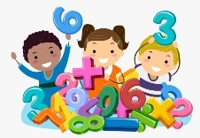 | Subitising  Reception | Skills  I can perceputally subitise within 3.  I can identify sub groups in larger arrangements.  I can create my own patterns for numbers within 4.  I have practiced using my fingers to represent quantities which they can subitise.  I have experienced subitising in a range of contexts, including temporal patterns made by sounds. |  | Skills  Continue from first half term.  I can subitise within 5, perceptually and conceptually, depending on the arrangements. | Skills  I am increasing my confidence in subitising by continuing to explore patterns within 5, including structured and random arrangements.  I have explored a range of patterns made by some numbers greater than 5, including structured patterns in which 5 is a clear part.  I have experienced patterns which show a small group and ‘1 more’.  I can continue to match arrangements to finger patterns. |  |  |  |  | Skills  I have explored symmetrical patterns in which side is a familiar pattern, linking this to ‘doubles’. |  | Skills  I can continue to practice increasingly familiar subitising arrangements including those which expose ‘1 more’ or ‘doubles’ patterns.  I can use subitising skills to enable me to identify when the patterns show the same number but in a different arrangement, or when patterns are similar but have a different number.  I can subitise structured and unstructured patterns, including those which show numbers within 10, in relation to 5 and 10.  I have been encouraged to identify when it is appropriate to count and when groups can be subitised. | Skills  I have developed fast recognition of up to 3 objects, (‘subitising’).  .
 | Composition  Reception | Knowledge  I know that all numbers can be made of 1’s. |  | Knowledge  I know that a whole is made from parts.  I know that some objects can be taken apart and some cannot. | Knowledge  I know which are the ‘missing’ or ‘hidden’ parts of 5.  I know that numbers within 10 can be composed of ‘5 and a bit’. |  |  |  |  | Knowledge  I know what an odd number is.  I know what an even number is. |  | Knowledge  I know what the number 10 is composed of. | Knowledge  I know some number bonds to 10 including doubling facts.
 | Composition  Reception | Skills  I have a deep understanding of 1-4.  I can compose my own collections within 4. |  | Skills  I have explored the concepts of wholes and parts.  I have explored the composition of numbers 1-5. | Skills  I have continued to explore the composition of 5.  I have explored the composition of 6, linking this to familiar patterns, including symmetrical patterns. |  |  |  |  | Skills  I have explored the composition of odd and even numbers, looking at the ‘shape’ of these numbers.  I am beginning to link even numbers to doubles.  I am beginning to explore the composition of numbers within 10. |  | Skills  I have explored the composition of 10.  I have revised number bonds to 5. | Skills  I have consolidated my understanding of concepts previously taught by working through a variety of contexts with different numbers.
 | Cardinality, ordinality and counting  Reception | Knowledge  I know that the last number spoken gives the number in the entire set.  I know some strategies to help me to count accurately.  I know that anything can be counted including actions and sounds. |  | Knowledge  I know that the last number spoken gives the number in the entire set.  I know some strategies to help me to count accurately.  I know that anything can be counted including actions and sounds. | Knowledge  I know that the last number spoken gives the number in the entire set.  I know some strategies to help me to count accurately.  I know that anything can be counted including actions and sounds. |  |  |  |  | Knowledge  I know that the last number spoken gives the number in the entire set.  I know some strategies to help me to count accurately.  I know that anything can be counted including actions and sounds. |  | Knowledge  I know that the last number spoken gives the number in the entire set.  I know some strategies to help me to count accurately.  I know that anything can be counted including actions and sounds. | Knowledge  I know that the last number spoken gives the number in the entire set.  I know some strategies to help me to count accurately.  I know that anything can be counted including actions and sounds.
 | Cardinality, ordinality and counting  Reception | Skills  I have had a wide range of opportunities to develop my knowledge of the counting sequence, including through rhyme and song.  I have had a wide variety of opportunities to develop 1:1 correspondence including by co-ordinating movement and counting. |  | Skills  I have continued to develop my counting skills.  I have explored the cardinality of 5, linking this to dice patterns and 5 fingers on 1 hand.  I am beginning to count beyond 5.  I am beginning to recognise numerals, relating these to quantities.  I can subitise and count. | Skills  I have continued to develop verbal counting to 20 and beyond.  I have continued to develop object counting skills, using a range of strategies to develop accuracy.  I have continued to link counting to cardinality, including using my fingers to represent quantities between 5 and 10.  I can order numbers, linking cardinal and ordinal representations of number. |  |  |  |  | Skills  I have continued to consolidate my understanding of cardinality, working with larger numbers within 10.  I am familiar with the counting pattern beyond 20.  I can add and subtract using number sentences. |  | Skills  I have continued to develop verbal counting to 20 and beyond, including counting from different starting numbers.  I have continued to develop confidence and accuracy in both verbal and object counting. | Skills  I can understand concepts previously taught by working through a variety of contexts with different numbers.  I can count beyond 20 and higher.
 | Comparison  Reception | Knowledge  I understand that sets can be compared according to a range of attributes, including by their numerosity. |  | Knowledge  I know that when every object in a set can be matched to one in the other set, they contain the same number and are equal amounts. | Knowledge  I understand the difference between odd and even numbers. |  |  |  |  | Knowledge  I understand the position of numbers 1-10 in the number system. |  | Knowledge  I know what the ordinal number system is. | Knowledge  I understand concepts previously taught.
 | Comparison  Reception | Skills  I can use the language of comparison , including ‘more than’ and ‘fewer than’.  I can compare sets ‘just by looking’.  I can verbally say which has more or less. |  | Skills  I can compare sets using a variety of strategies, including ‘just by looking’ , by subitising and by matching.  I can compare sets by matching,  I can compare equal and unequal groups. | Skills  I can compare sets using the language of comparison, and play games which involve comparing sets.  I can compare sets by matching, identifying when sets are equal.  I can explore ways of making unequal sets equal.  I can explore the difference between odd and even numbers. |  |  |  |  | Skills  I can compare numbers , reasoning about which is more, using both an understanding of the ‘howmanyness’ of a number and its position in the number system. |  | Skills  I can order sets of objects, linking this to my understanding of the ordinal number system.  I can compare numbers to 10 using the vocabulary of more than and less than.  I can share quantities equally. | Skills  I understand concepts previously taught by working through a variety of contexts with different numbers.
 | Pattern  Reception | Knowledge  I know that a pattern repeats. |  | Knowledge  I know that a pattern should be consistent. | Knowledge  I know that a pattern has a ‘unit’ which repeats. |  |  |  |  | Knowledge  I know that a pattern should be consistent and repeating. |  | Knowledge  I know that patterns can be applied to colours, objects, movements and sounds. | Knowledge  I know some of the patterns in my natural environment.
 | Pattern  Reception | Skills  I can continue an AB pattern.  I can copy an AB pattern.  I can make my own AB pattern |  | Skills  I can spot an error in an AB pattern.  I can identify the unit of repeat. | Skills  I can continue an ABC pattern.  I can continue a pattern which ends mid unit. |  |  |  |  | Skills  I can make my own ABB, ABBC patterns .  I can spot an error in an ABB pattern. |  | Skills  I can symbolise the unit structure.  I can generalise structures to another context or mode.  I can make a pattern which repeats around a circle. | Skills  I can make a pattern around a border with a fixed number of spaces.  I can spot patterns around us.
 | Measures  Reception | Knowledge  I know a range of vocabulary to discuss measures. |  | Knowledge  I know strategies to use to compare different amounts | Knowledge  I know strategies to use to make sensible estimates and predictions. |  |  |  |  | Knowledge  I know how to use units to compare things. |  | Knowledge  I know that a longer object measures more units than a shorter object.  I know that a heavier object weighs more units than a lighter object. | Knowledge  I understand yesterday and tomorrow.
 | Measures  Reception | Skills  I can recognise attributes .  Long/tall/full/heavy |  | Skills  I can compare amounts of continuous quantities | Skills  I can show an awareness of comparison in estimating and predicting. |  |  |  |  | Skills  I can compare indirectly. |  | Skills  I can recognise the relationship between the size and the number of units. | Skills  I can sequence pictures from familiar short stories/ nursery rhymes.  I can talk about times of the day.  I can sequence pictures from my daily routines.
 | Shape and Space  Reception | Knowledge  I know that objects and places can be viewed from a range of angles. |  | Knowledge  I know that 3D shapes fit together to make larger models. | Knowledge  I know that a triangle, a rectangle and a square all have straight sides. |  |  |  |  | Knowledge  I know a triangle has 3 sides.  I know a circle is curved.  I know a square has 4 sides. |  | Knowledge  I know that a triangle has 3 points.  I know that a square and rectangle have 4 corners.  I know that a square has 4 sides the same length.  I know that a circle has 1 curved side. | Knowledge  I know that a rectangle can fit 2 squares inside it.  I know that a circle folded into 2 would become a semi-circle.  I know that 2 triangles would fit inside a square.
 | Shape and Space  Reception | Skills  I am developing spatial awareness: experiencing different viewpoints.  I am developing spatial vocabulary. |  | Skills  I am developing shape awareness through construction.  I can represent spatial relationships. | Skills  I can identify similarities between shapes. |  |  |  |  | Skills  I show an awareness of properties of shape. |  | Skills  I can describe the properties of shapes. | Skills  I have an awareness of relationships between shapes.
Science  (Understanding the World)  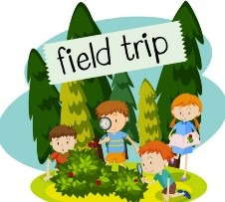 | Science  Reception | Knowledge  I know my 5 senses.  I can name my main body parts.  I know that humans can look different.  I know why I need to brush my teeth.  I know the names of a range of animals (farm/ wild/pets).  I know how animals are different.  I know how animals are the same.  I know how to care for animals.  I know an animal song/ rhyme.  I know the life cycle of one animal |  | Knowledge  I have a good general knowledge about living things and the natural world.  I can recall features of different plants and animals.  I know some ways to care for the world environment.  I know what rubbish can do to our environment and animals.  I know some ways that things can be recycled. | Knowledge  I know how to care for plants.  I know vocabulary to describe plants in detail. (e.g describe a daffodil, moss on a stone, blossom on trees).  I know that some trees change throughout the year and others do not. |  |  |  |  | Knowledge  I know some important processes and changes in the natural world, including states of matter.  (Ice melting/ water freezing/ sound causing a vibration/  I know what light is.  I know that light is made of all colours of the rainbow.  I know we need light to see.  I know dark is the absence of light.  I know that I can make shadows when I block the light.  I know that a force makes something move.  I know what a magnet is.  I know that some materials are magnetic (stick to a magnet).  I know that objects that float ‘push’ against the water. |  | Knowledge  I know some important processes and changes in the natural world including the effects of changing seasons on the natural world around them.  I know different weather types and how they differ in different places.  I know how to care for the air we breathe?  I know that the Earth is tilted and spins on its axis to cause day and night, seasons and climate.  I know that clouds and fog are made up of water droplets or frozen crystals of water. | Knowledge  I know a full range of materials (wood, metal, plastic, glass, paper, stone).  I know some ways we can care for old buildings like castles.  I know which is the strongest material to build a castle with.  I know what would happen to a mud castle if it rained.  I know some materials that can be recycled.  I know the difference between metallic and non-metallic objects.
 | Science  Reception | Skills  I can label my body parts.  I have learnt some of the purposes of parts of my body.  I can make observations about animals discussing similarities and differences.  I can discuss animals behaviour in different weather and seasons.  I can label animal body parts.  I can match animals to their young.  I can talk about my pets. |  | Skills  I can explore the natural world around me using my senses to describe what I can see, hear and feel.  I can talk about features of the environment I am in.  I have learnt about different  environments.  I can explore and ask questions about the natural world around me.  I can go on a minibeast hunt.  I can sort animals according to where they live.  I can group animals by familiar features (size, colour, shape). | Skills  I can make observations about plants discussing similarities and differences.  I can recognise familiar plants.  I can label the different parts of a plant.  I can plant and grow herbs and use my senses to investigate.  I can grow a sunflower and measure it as it grows.  I can pick edible berries.  I can visit a garden/ allotment/ nature reserve to explore a range of plants.  I can name trees in the school woodland. |  |  |  |  | Skills  I can make shadows using a light source and different objects.  I can give examples of forces all around me.  I can try to explain how mechanical toys might work.  I have explored through interaction and hands-on experiences.  I can sort materials into those that float or sink and give reasons why that might be. |  | Skills  I notice, observe and talk about seasonal changes.  Note and record the weather.  Select texts about weather and seasons.  I can observe outdoors.  I can investigate and measure with a rain gauge.  I can discuss what to wear in different weathers.  I can investigate why water in an open container disappears. | Skills  I understand the terms ‘same’ and ‘different’.  I can explain why materials are the same or different.  I can investigate and explore properties of materials in loose part play/ junk modelling.  I can take part in cooking activities.  I can explore collections of materials with similar or different properties and changes I notice.  I can sort objects into groups based on their material.  I can squeeze and manipulate different materials.  I can use magnifying glasses and I-pad apps.  I can look at magnified objects and guess what I see. (Explorify).  I can change the sensory nature of sand by adding other materials.
History  (Understanding the World) | Chronology  Reception | Knowledge  I know who my family members are and their relationship to me. |  | Knowledge  I know about my own life story and how I have changed up to now. | Knowledge  I know the days of the week in the correct sequence. |  |  |  |  | Knowledge  I know some of the months of the year in sequence.  I know which month of the year my birthday is in. |  | Knowledge  I know the seasons of the year in sequence. | Knowledge  I know the main events of my school year.  I know about my own life story and how I have changed.
History  (Understanding the World) | Chronology  Reception | Skills  I can describe people who are familiar to me. |  | Skills  I can use the language of time when talking about past/present events in my own life and in the lives of others.  I can sequence my family members. | Skills  I can explain the key differences between what my family members can do.  I can visually represent my own day on a simple timeline. |  |  |  |  | Skills  I can sequence a familiar set of events.  I can talk about changes in my own lifetime, by creating a personal timeline. |  | Skills  I can describe a familiar sequence of events using words such as, first… then…  I can recount an event or journey orally, pictorally and/or captions. | Skills  I can order experiences in relation to myself and others, including stories.  I can re-tell life experiences that I have had.
History  (Understanding the World) | Historical Knowledge  Reception | I can talk about the lives of people around me and their roles in society including historical figures.  I am developing a sense of continuity and change.  I can compare and contrast characters from stories throughout the year, including figures from the past.
History  (Understanding the World) | Historical Knowledge  Reception | Family Life | Mary Anning |  |  | Local Legends |  | Samuel Pepys |  |  |  | Robert Louis Stephenson/ Wright Brothers |  | Houses and Homes
History  (Understanding the World) | Historical Knowledge  Reception | I am developing an understanding of past and present family life through texts and images. | I can talk about historical characters from a range of cultures after listening to stories about them. |  |  | I can use songs, poems, puppets and role play to explore characters from the past. |  | I can explore common themes from stories, such as bravery, difficult choices and kindness. I can talk about my experiences with these. |  |  |  | I am learning about the discovery of the telephone/ ways to communicate. |  | I am learning about historical evidence that tells us about Homes in the past.
History  (Understanding the World) | Historical enquiry  Reception | I can explain similarities and differences with pictures, stories, artefacts and accounts from the past.
History  (Understanding the World) | Historical enquiry  Reception | Knowledge  I know some things that families did in the past.  I know some things families do in the present. |  | Knowledge  I know what a fossil hunter does.  I know that fossil hunters in the past have changed what we know about the past today.  I know that Marry Anning found a very famous plesiosaur fossil.  I know what life was like in Mary Anning’s times. |  |  | Knowledge  I know some stories from the local area.  I know about the past through these stories. |  |  | Knowledge  I know a range of different occupations people do.  I know which job/s I would like to do.  I know what life was like for people at the time of the great fire of London. |  | Knowledge  I know about the past through the stories about how people travelled.  I know how the way we travel has changed over time. |  | Knowledge  I know a range of different homes of the past.  I know which home I would like to live in.  I know that homes have changed over time.
History  (Understanding the World) | Historical enquiry  Reception | Skills  I can comment on images of familiar situations in the past (family life).  I can talk about the lives of immediate family, people around me. |  | Skills  I can comment on images of situations in the past.  I show an interest in a wider range of occupations.  I can ask questions and use different sources to answer.  I can decide if a picture is in the past or present. |  |  | Skills  I can comment on images of legends from the past.  I can talk about these stories in more detail.  I can ask questions abut these stories. |  |  | Skills  I can ask questions to Samuel Pepys.  I can use vocabulary related to occupations in play.  I can describe people who are familiar to me. (delivery and shop staff, hairdressers, police, fire service, nurses, doctors and teachers.)  I can share my experiences.  I can identify similarities and differences in jobs. |  | Skills  I can comment on images of familiar situations in the past.  I can talk about past and present events in my life and those I have learnt about.  I can talk about the lives of people in my community and the important roles that they play.  I can talk about key roles people have in society both in the present and in the past. |  | Skills  I can comment on images of familiar situations in the past.  I can talk about the past and present events in my own life and those I have learnt about.  I can describe features of objects, people, places at different times and make comparisons.  I can ask questions to family members.
History  (Understanding the World) | Interpretation Skills  Reception | Knowledge  I know what was the same and what was different in the past in family life. |  | Knowledge  I know what was the same and what was different in the past using what I know about fossils. |  |  | Knowledge  I know what was the same and what was different in the past in the local area. |  |  | Knowledge  I know what was the same and what was different in the past at the time of the great fire. |  | Knowledge  I know what was the same and what was different in the past with travel. |  | Knowledge  I know what was the same and what was different in the past at the time of my parents and grandparents when they were children. (Homes)
History  (Understanding the World) | Interpretation Skills  Reception | Skills  I understand the terms ‘same’ and ‘different’. |  | Skills  I can spot things that are the same and different in different contexts. |  |  | Skills  I can compare and contrast characters from stories. |  |  | Skills  I can comment on images of familiar situations and events (occupations) in the past. |  | Skills  I can draw on my own experiences and those in class.  I can describe images of familiar situations in the past using books. |  | Skills  I can draw on my own experiences and those in class.
Geography  (Understanding the World) | Geographical Enquiry  Reception | Knowledge  I know that there are many countries around the world.  I can name some countries in the world.  I know that some people in other countries may speak in different languages.
Geography  (Understanding the World) | Geographical Enquiry  Reception | Skills  I can describe environments using stories and maps.  I have an understanding of life in other countries, through settings, characters and events from books.  I can comment about different places within stories and recognise that different places have different features.  I can make comparisons between life for children in different countries.  I can compare life in this country to other countries.  I can learn about different countries from non-fiction texts.
Geography  (Understanding the World) | Focus country | France |  | Kenya (Africa) |  |  | Antarctica |  |  | United Kingdom (England, Ireland, Scotland, Wales) | India |  |  | Australia
 | Geography  Reception | Knowledge  I know about features of the immediate environment (countryside landscape).  I can name the road and the village that the school is located in. |  | Knowledge  I know that some environments are different to the one where I live.  I am beginning to name specific features of the world, natural and man-made. |  |  | Knowledge  I can name the road and the village that the school is located in.  I know the local landmarks in my area.  I know that simple symbols are used to identify features on a map. |  |  | Knowledge  I can name specific features of the world, natural and man-made. | Knowledge  I know my address.  I know which country I live in.  I know that simple symbols are used to identify features on a map.  I know I can use maps to locate objects in ‘real life’. |  |  | Knowledge  I know about people who help us within the community.
 | Geography  Reception | Skills  I can talk about what I see in my own environment using a range of vocabulary (school and home).  I can read common signs and logos.  I can talk about members of my immediate family and community.  I can represent my local environment/ make physical features in sand play and construction. |  | Skills  I can draw a picture to represent a place.  I have explored different families around the world.  I can talk about some of the holidays I have been on.  I can use geographical vocabulary in role play travel agents.  I can use pictures to compare and contrast.  I can look closely at similarities and differences.  I can show my learning through play with a diverse range of props, puppets and dolls. |  |  | Skills  I can make comparisons between objects relating to size, and length.  I can talk about my local environment (road, park, library).  I can draw information from a simple map.  I can draw a picture map to represent a place.  I can ask questions about my immediate environment and other places. |  |  | Skills  I can use picture maps.  I can program a beebot to move along a track or small world set up in a specific direction.  I can use photos and pictures to locate places and place on a simple map.  I can draw a simple map to represent a place.  I can identify similarities and differences between homes in my country.  I can find out about my local area by visiting places and talking to people. | Skills  I can use technology e.g beebots I am beginning to show spatial awareness.  I can draw a picture map to represent a place.  I recognise that some environments are different to the one where I live.  I can use pictures to compare and contrast.  I can identify on a map different environments to where I live. |  |  | Skills  I can describe a familiar route.  I can create own map using grid paper and symbols.  I can compare places visited and their features.  I can comment on and ask questions about the different parts of the local community.  I notice features using aerial views of the school setting.  I can discuss routes and locations, using words like ‘in front of’ and ‘behind’.  I can follow simple directions like up and down, forwards and backwards.  I can use maps to locate objects in ‘real life’.  I can use technology e.g beebots I am beginning to show spatial awareness.  I can use positional language.  I can talk about my local environment (road, park, library).
RE | RE  Reception | CREATION  I know that collective worship is part of the life of the school community.  I know that I am special. |  | INCARNATION  I know that people have different beliefs and celebrate special times in different ways.  I know that God came to Earth as a baby, Jesus Christ, Son of God.  I know that Jesus showed us what God is like on Earth.  I know that people are God’s treasured possessions and he loves them all equally. |  |  | SALVATION  I know that people have different beliefs and celebrate special times in different ways.  I know about some religious festivals.  I am beginning to express my own opinions and thoughts about the religious material studied. |  |  | SALVATION  I know that people around the world have different religions. | What makes stories special?  I can listen to religious stories and talk about their meaning.  I can recognise some religious words and symbols. |  |  | What happens in our church?  Knowledge  I know that some places are special to members of my community.  I know about how some people express their beliefs (e.g. what happens in church).
RE | RE  Reception | Skills  I can talk to the local vicar and ask them questions.  I can show interest in the world around me and ask questions about what I see and experience.  I understand how to care for an animal/ pet. |  | Skills  I have visited church and chapel and contrasting places of worship in the city for a variety of faiths. I can compare the similarities and differences.  I have a growing understanding of the wider world.  I can work with others to make the world a good place.  I am beginning to understand what is important to me. |  |  | Skills  I can be curious and interested in finding out about people.  I have investigated different beliefs and celebrations (Chinese New Year). |  |  | Skills  I have spoken to people from different faiths and shared their experiences.  I am beginning to understand what is important to some people of faith.  I am beginning to express my own opinions and thoughts about the religious material studied. | Skills  I am beginning to express my own opinions and thoughts about the religious material studied. |  |  | Skills  I am beginning to express my own opinions and thoughts about the religious material studied.  I understand why some places are special to members of their community.
COMPUTING | Computing  Reception | Technology  I can talk about how I can use the internet to find things out.  I can identify devices I could use to access information on the internet.  I can give simple examples of how to find information (e.g. search engine, voice activated searching). |  | Digital Writing  Privacy and Security  I can identify some simple examples of my personal information (e.g. name, address, birthday, age).  I can describe the people I can trust and can share this with; I can explain why I can trust them.  I know that a password is secret.  Copyright and Ownership  I know that work I create belongs to me.  I can name my work so that others know it belongs to me. |  |  | Robots  Online Bullying  I can describe ways that some people can be unkind online.  I can offer examples of how this can make others feel.  I can talk about how I can use the internet to find things out.  Online Reputation  I can identify ways that I can put information on the internet |  |  | Data  Online Relationships  I can recognise some ways in which the internet can be used to communicate.  I can give examples of how I (might) use technology to communicate with people I know. | Digital painting  Self-Image and Identity  I can recognise that I can say ‘no’ / ‘please stop’ / ‘I’ll tell’ / ‘I’ll ask’ to somebody who asks me to do something that makes me feel sad, embarrassed and upset.  I can explain how this could be either in real life or online. |  |  | Animation  Health, Well-being and lifestyle  I can identify rules that help keep us safe and healthy in and beyond the home when using technology.  I can give some simple examples.
 |  | I can wait a short amount of time for something I want e.g.: a computer loading / an App to work.  I can with support try new things. E.g.: a computer programme / Beebots. |  | I know how to use an iPad or tablet appropriately. I know how to use my fingers on a touch screen, and control a mouse/touchpad on a computer. |  |  | I know how to work a simple programable toy.  I can select and use technology for particular purposes. |  |  | I know how technology is used in my own home.  I know that technology has changed since my adults were young. | I know how to use a camera and how to draw on an i-pad. |  |  | I can safely use a range of technology for a purpose, including making my own video.
Art and Design  (Expressive Arts and Design)  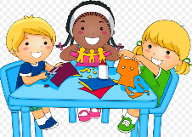 | Breadth of study  Exploring and Developing Ideas and work  Reception | I can use a range of different techniques and a variety of materials.  I can explore different surfaces to work on; paving, floor, tabletop, easel.  I can look at some country crafts in order to widen my ideas. |  | I can share my creations.  I can talk about process and evaluate my work.  I can create collaboratively sharing skills/ techniques.  I can paint pebbles. |  |  | I can experiment with different textures through collage.  I can explore recycling with boxes.  I can explore long strips of paper. |  |  | I have visited a museum/ art gallery to give me inspiration and encourage me to talk about Art and Artists.  I can safely explore different techniques for joining materials.  I can use different textures in creations and combine media. | I can explore and use a variety of artistic effects to express my ideas and feelings.  I can plan a design before starting.  I can ask questions to an artist. |  |  | I can make soft furnishings for a home role play area.  I know what textiles are.  I can describe and sort textiles.  I can cut and join textiles using tape and glue.  I can make a patchwork pattern.  I can use food colouring to dye a piece of fabric
 | Artists to study colour/ movement/ line/ emotion (different times and cultures). | Self portraits |  | Drawing fossils  3D clay fossils |  |  | Collage  Scenes from legends |  |  | Archimaldi  Fruit and veg people | LS Lowry  Drawing/ Line/ Painting |  |  | William Morris  Printing/ Pattern  Flowers/ Nature
 | Interesting objects to draw | Faces |  | Fossils. Shells/ Rocks |  |  | Unusual plants |  |  | People  Fruit and Veg | Cars/ planes/ trains |  |  | Flowers/ nature
 | Drawing  Reception | Skills  I can draw simple shapes and lines.  I can use drawing materials to create pictures with a range of lines and shapes. |  | Skills  I can draw simple things from memory/ things I observe.  I can explore textures built from lines (rubbings).  I can explore lines in wet/dry sand. |  |  | Skills  I can colour in a picture using appropriate colours within the lines.  I can colour alongside my teacher. |  |  | Skills  I can draw a self-portrait using a mirror.  I can draw bodies of an appropriate size. | Skills  I can use a range of shapes and colours to represent observational drawings.  I can draw lines in random patterns and lines in regular patterns. |  |  | Skills  I can draw with detail.  I can draw lines from observation e.g lines on my hand, lines on a leaf, vegetable, shell, fossil.
 | Painting  Reception | Knowledge  I can name colours. I know dull colours and bright colours.  Skills  I experiment with colour to make creations.  I can experiment with mixing colours. |  | Knowledge  I know what colours make me think of.  Skills  I experiment with colour and texture with paint.  I can use a paintbrush to form lines and circles. |  |  | Knowledge  I know how to observe closely.  Skills  I can paint simple things from memory or observation. |  |  | Knowledge  I know the names of primary colours.  I know that primary colours cannot be mixed from other colours.  Skills  I can mix primary colours to make secondary colours.  I can experiment printing with paint. | Knowledge  I know some different tools I can paint with.  I know what a repeat pattern is.  Skills  I can choose tools I need to enhance my work.  I can use thin brushes to add detail.  I can paint with a range of tools. |  |  | Knowledge  I know which Primary colours make secondary colours.  Skills  I can mix colours.  I can mix different shades of secondary colours.
 | 3D Form / Collage  Reception | Knowledge  I know what a collage is.  Skills  I can explore form using play dough.  I can use a rolling pin.  I can make a collage cutting different shapes from paper. |  | Knowledge  I know what clay is, where it comes from and what it is used for.  Skills  I can explore form using air drying clay.  I can make something with clear intentions.  I can talk about what I’ve made.  I can roll, pull, pinch, twist, stroke, wet, burrow, prod and poke clay. |  |  | Knowledge  I know that collages can be made with different materials.  Skills  I can engage in loose part play.  I can make a collage with different types of paper. |  |  | Knowledge  I know why an effective construction needs a careful plan/ design.  Skills  I can design a construction and build it and name it. | Knowledge  I know some ways to join materials.  Skills  I can build models which replicate those in real life.  I can decorate my model.  I can use masking tape and Sellotape. |  |  | Knowledge  I know what 3D Art is.  Skills  I can explore form using construction materials.  I can make a collage using a range of materials.  I can cut a slit into a box or tube to join another piece of card to it.
Design and Technology  (Expressive Arts and Design) | Reception | Knowledge  I know the main features of a strong structure.  Skills  I can select and name the tools needed to work the materials e.g. scissors for paper.  I can design and build a stick structure. |  | Knowledge  I know the names of the materials I am using.  Skills  I can explain what I am making and which materials I am using.  I can build with junk.  I can fold paper to make creations. |  |  | Knowledge  I know the names of the materials I am using.  Skills  I can select materials from a limited range that will meet a simple design criteria e.g. shiny.  I can design and make a mask for a character. |  |  | Knowledge  I know that I need to follow a sequence of instructions to make a meal.  Skills  I can explore my favourite recipes and how to make them. | Knowledge  I know what fabric is and how it can be used.  Skills  I can explore ideas by rearranging materials.  I can make independent choices about the resources needed and talk about my creations. |  |  | Knowledge  I know why an effective construction needs a careful design/ plan.  Skills  I can build based on photos of instruments.  I can describe simple models or drawings of ideas and intentions.  I am beginning to plan a design before starting.  I can choose the most appropriate tools and materials for the job.  I can make an instrument.
Design and Technology  (Expressive Arts and Design) | Working with tools, equipment, materials and components to make quality products  Reception | Skills  I am starting to build structures, joining components together.  I can recognise balance and how it can be achieved. |  | Skills  I can use glue and masking tape for sticking pieces of scrap materials onto cardboard boxes.  I am beginning to create my design using basic techniques.  I can join materials with different sorts of glue. |  |  | Skills  I can use technical vocabulary when appropriate.  I can safely explore different techniques for joining materials.  I can use a glue gun with supervision. |  |  | Skills  I am beginning to use scissors to cut straight and curved edges.  I can make imaginative and complex small worlds with blocks and construction kits (e.g a city with a park.). | Skills  I can use adhesives to join material.  I can discuss my work as it progresses.  I can talk about the process and evaluate my work.  I can use hole punches to punch holes.  I can use paperclips and fasteners. |  |  | Skills  I have explored using/ holding basic tools such as a saw or hammer.  I can use a hammer and nails.  I have looked at simple hinges, wheels and axles.  I can build connecting structures.
Design and Technology  (Expressive Arts and Design) | Evaluating processes and ideas  Reception | Skills  I can say what I like and do not like about items I have made. |  | Skills  I can say what I like and do not like about items I have made and attempt to say why. |  |  | Skills  I am beginning to talk about my designs as they develop and identify good and bad points. |  |  | Skills  I am starting to talk about changes made during the making process. | Skills  I can discuss how closely my finished products meet my design criteria. |  |  | Skills  I can discuss how closely my finished products meet my design criteria.
Design and Technology  (Expressive Arts and Design) | Food and nutrition  Reception | Knowledge  I know words to describe the taste, smell, texture and feel of food.  Skills  I am beginning to be able to describe familiar food products like fruit and vegetables.  I can stir, spread, knead and shape a range of food and ingredients.  I can measure and weigh food items, non-statutory measures e.g. spoons, cups. |  | Knowledge  I know why I need to measure food for a recipe.  Skills  I can measure and weigh food items using non-statutory measures e.g. spoons, cups. |  |  | Knowledge  I know what ingredients are.  I can name the tools needed to mix food.  Skills  I can stir, spread, knead and shape a range of food and ingredients. |  |  | Knowledge  I know the names of some familiar fruit and vegetables.  Skills  I have explored familiar food products e.g. fruit and vegetables. I can describe them. | Knowledge  I know that my diet needs to contain a variety of foods.  Skills  I am beginning to work safely and hygienically.  I am starting to think about the need for a variety of foods in a diet. |  |  | Knowledge  I know that instructions need to be followed in an ordered sequence.  Skills  I can follow a simple recipe to make an end product.
Music  (Expressive Arts and Design ) | Music and songs to share | Head, shoulders, knees and toes  Hokey Cokey  Do your ears hang low? |  | She’ll be coming round the mountain.  Sticks and stones |  |  | Round and round the garden  Mulberry bush |  |  | Ring o ring o roses  Londons Burning  Lonon Bridge | Rain rain go away (high/low) simple pitch.  Sing a rainbow  The wheels on the bus  Row row your boat |  |  | Hickory dickory dock
Music  (Expressive Arts and Design ) | Music Reception | Knowledge  I know when a sound is high or low. |  | Knowledge  I know that music is a pattern of sounds. |  |  | Knowledge  I know that music sounds different in different countries.  I know what a percussion instrument is.  I know that a melody goes up and down. |  |  | Knowledge  I know that movements need to match the music.  I can name some percussion instruments. | Knowledge  I know the names of a range of instruments.  I know that pitch is ………. |  |  | Knowledge
Music  (Expressive Arts and Design ) | Music Reception | Skills  I can sing and perform nursery rhymes in a familiar group.  I can listen attentively and talk about music, expressing my feelings and responses.  I can play pitch matching games.  I can copy short hummed or sung phrases. |  | Skills  Invite a musician/s into school to widen experiences.  I can listen to music and discuss changes and patterns as the piece of music develops. |  |  | Skills  Introduce children to music from across the globe.  I can experiment with a range of percussion instruments and their sounds.  I can sing in a group or on my own, increasingly matching the pitch and following the melody.  I can make rhythms with body percussion. |  |  | Skills  I can move in time to the music.  I can use ribbons and streamers to move to the music.  I can play a range of percussion instruments following a simple beat.  I can sing call and response songs.  I can echo phrases of songs sung to me. | Skills  I can play an instrument following a musical pattern.  I can use instruments to compose my own movement patterns.  I can play pitch matching games.  I can copy short hummed or sung phrases.  I have listened to British music, traditional and folk.  I can make musical instruments by filling bottles of water in water play. |  |  | Skills  I can create my own song.  I can choose instruments to use to play along.  I have recorded and shared my musical creations.  I can create my own instrument/ shaker.
Drama  (Expressive Arts and Design ) | Drama  Reception | Skills  I can role-play based on a fiction / non-fiction book.  I can make and play with a family scene.  Possible role-play – home corner, pet shop, doctors, opticians, dentist |  | Skills  I can access role play and small world resources sometimes playing with others to develop storylines.  I can develop my ICT skills through role-play e.g telephone, computer, etc..  Possible role-play – fossil shop, camp site |  |  | Skills  I can create narratives based around stories.  I can talk about dance and performance art, expressing my own feelings and responses.  I can use props with imagination e.g, fabric for capes.  Possible role-play – castle |  |  | Skills  I can collect resources to develop their own role play storylines with others.  I can develop my writing skills within role-play.  I can use puppets.  Possible role play – Museum. Art studio | Skills  I can talk about what different people do in role-play situations.  I can talk in the language of different roles.  Possible role-play – train station/ airport// aeroplane |  |  | Skills  I can make up stories using complex ‘small worlds’ with blocks and construction kits/ puppets.  I can take part in simple pretend play, using an object to represent something else (even though they are not similar).  Possible role play –, homes from around the world

